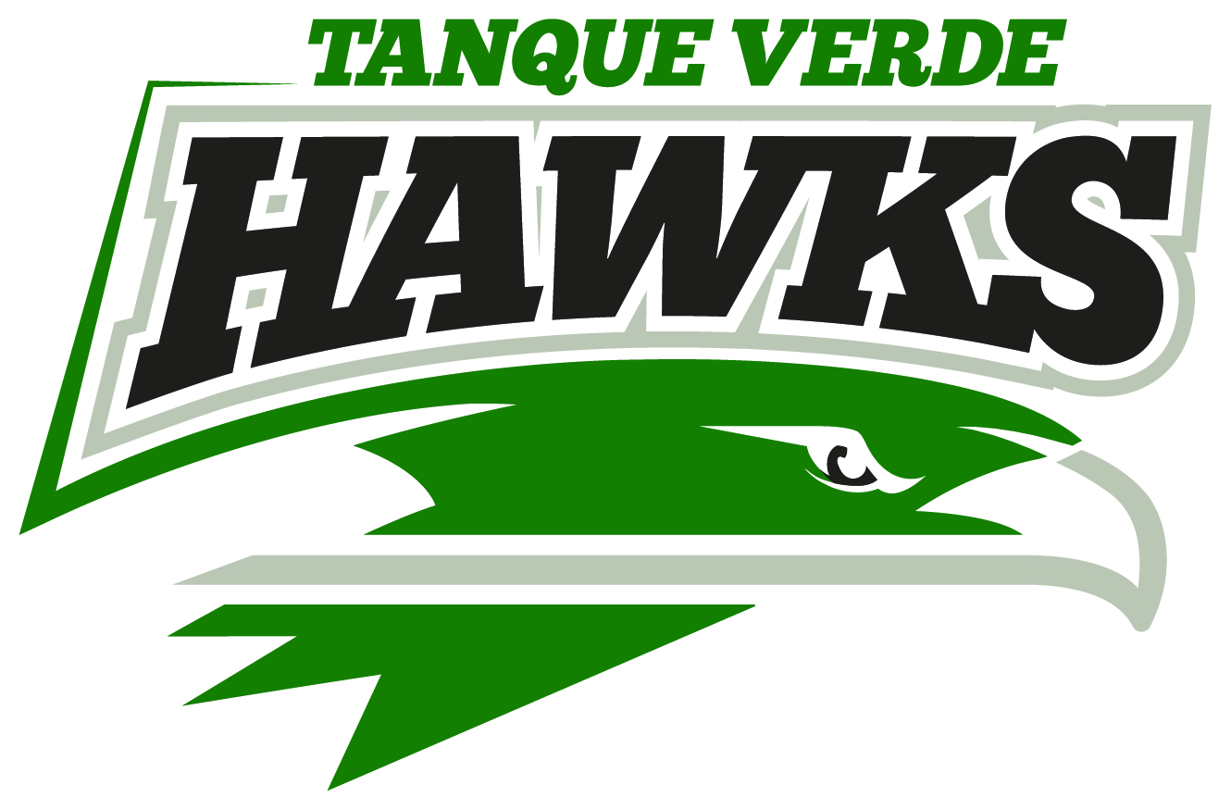
EVERYONE WELCOME!!
Incoming Hawks Night 2018
at
Tanque Verde High School
Wednesday, January 17th, 2018
6pm – 7:30pm
Multipurpose Room (MPR)
Visitors can take a tour of the campus, meet teachers and administrators, speak with current TVHS students, and learn more about our clubs and activities.
For questions, contact Rhonda Burnett, rburnett@tanq.org or 520-760-0801, ext.1004

