Tae Kwon Do Karate at St. Michaels

New students welcome!

Mondays - Parish Center

January 22 – May 21

All Grades 3:30-4:30

Only $189 for Full Semester

Double Dragon Uniform $35

Checks payable to: Vincent Gillenkirk

.

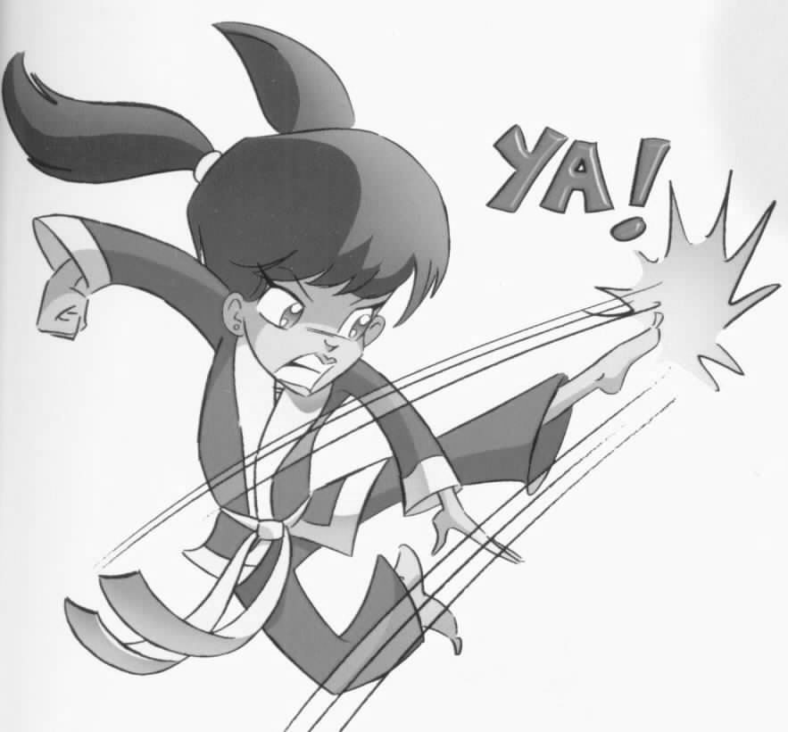

Concentration * Coordination * Confidence

Master Instructor Vincent Gillenkirk

Assistant Instructor Joshua Deets

For questions: Mr. Gillenkirk 990-5834 or vdawa@cox.net

Return this form to the Front Office

Student________________________________________Birth date______Grade__
Email___________________________________
Phone 1___________________Phone 2__________________
Parents/Guardians______________________________________________________ Medical conditions/medications___________________________________________

I understand that, as in any athletic activity, accidents may occur which could involve injury to my child or others. I do hereby agree to release Ki Center Martial Arts, its employees, instructors, and Mr. Gillenkirk from all liability for any and all injuries, damages, sickness, negligence, or death, and I agree to indemnify and hold blameless all partners stated above as a result of any suit or claim for damages. In addition, I give authority to Mr. Gillenkirk to administer first aid, and I give any and all consents required to secure necessary medical attention.
I agree to individually provide for any possible future medical expenses that may be incurred as a result of any injury sustained while participating in any class or activity connected with the organization. This acknowledgment of risk and waiver of liability, having been read thoroughly and understood completely, is signed voluntarily as to its content and intent.

Signature_____________________________________ Date________________

